Kazeem Oladejo

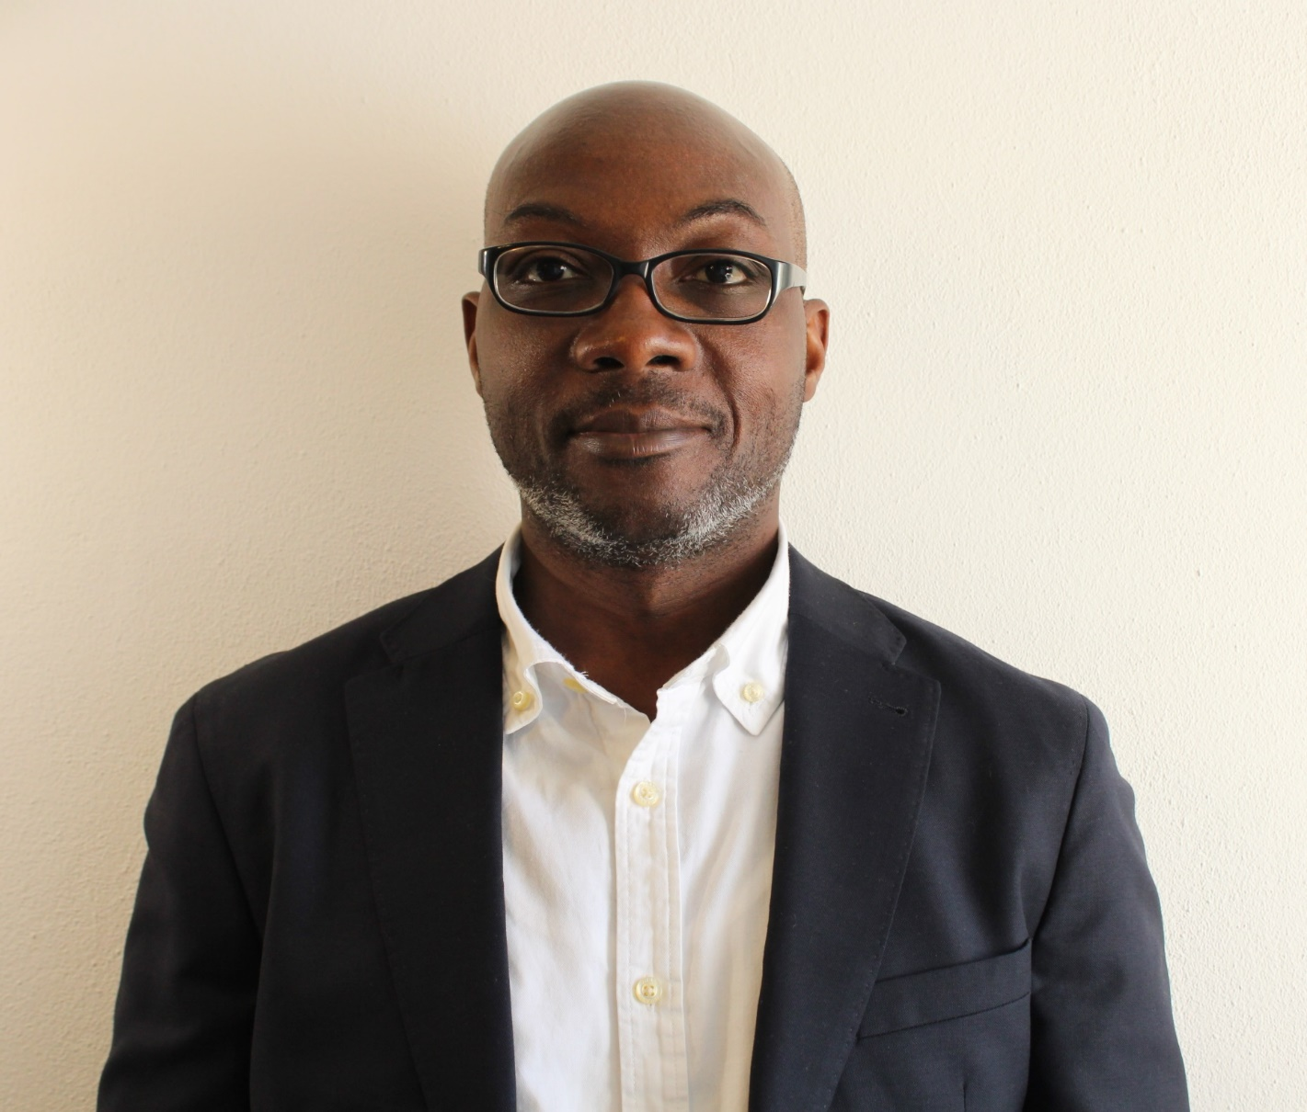
Babatunde Kazeem Oladejo is a PhD candidate at the department of Computer Science, SSST BiH / University of Buckingham, UK. Prior to starting the PhD program in 2019, he worked as an IT Enterprise Content Management (ECM) specialist with various companies in the USA and Canada for over 18 years. He completed his MSc and BSc degree with honors at the department of Computer Science, University of Lagos, Nigeria. His research interest areas include Machine Learning, Text Mining, Computational Grounded Theory and Social Informatics.
kazeem.oladejo@ssst.edu.ba

Current Work Experience
Teaching Assistant, University SSST, Sarajevo, BiH
Mar 2022 – Present
Create and deliver lab sessions for CS360 Business Intelligence course covering Data Warehousing, SQL Server Database, Analysis Services, Integration Services, Reporting Services and Power BI modules.

Previous Work Experience
Independent ECM Consultant
Aug 2016 - Dec 2018
Major projects include:
- ECM Performance Counts, ON, Canada
- ECM Assessment for City of San Diego, CA, USA
- ECM Consulting for New Jersey Transit, NJ, USA

SAP xECM Analyst, Bendix Commercial Vehicle Systems LLC, OH, USA
Sep 2015 - Jul 2016
Responsible for project management, business analysis, technical design and configuration of OpenText and SAP Extended ECM project solutions. Major projects/initiatives include: SAP PPM (Project and Portfolio Management), Contracts Management xECM: implementation for Bendix Purchasing department, xECM / Content Server Upgrade (version 10.0 to 10.5); SharePoint Extranet Support.

Principal Consultant, Zeleni Papir Solutions, ON, Canada
Dec 2013 - Dec 2015
Leader for a start-up ECM consulting firm, providing on-site and off-site client guidance and support for OpenText Content Server 10 and SharePoint 2013 implementations. Clients: Ministry of Transportation, ON, Canada (design of driver records repository and knowledge management workflows) and SaskPower, SK, Canada (content migration to SharePoint 2013/AGA/OpenText Content Server 10 for records management. Design Document Review/Approval workflow).

Tech Lead / Solutions Architect, SaskPower, SK, Canada
Dec 2011 - Dec 2013
Responsible for planning and design of an enterprise-wide integrated ECM (using OpenText Content Server and SharePoint) that ensure records compliance with the Saskatchewan Archives Board (SAB) regulation.

IT Manager / Sr. Systems Associate, Celgene Corporation, USA / Europe
Feb 2004 - Jul 2011
Created the Livelink document management / Enterprise Content Management practice for Celgene Pharmaceuticals. Managed and mentored up to 8 staff members and consultants.

Livelink Consultant, Canadian National Institute for the Blind, ON, Canada
Jan 2003 - Jan 2004
Partnered with vendors (Opentext, Microsoft, Navantis) and other consultants to facilitate the development of a customized Livelink 9.1 SP3 solution for the CNIB’s Digital Asset Management system.

Systems Analyst, Greater Toronto Airports Authority, ON, Canada
Aug 2001 - Dec 2002
Collaborated with in-house teams, vendors (Opentext, Formark) and consultants (LGS) to facilitate the implementation of Livelink 9.0 (and subsequent upgrade to 9.1) for GTAA’s Intranet and Extranet solutions.

Education
1996 Master of Science (Msc.), Computer Science, University of Lagos, Nigeria
1992 Bachelor of Science (BSc.), Computer Science, University of Lagos, Nigeria

Published Research Papers
Oladejo, Babatunde, and Sunčica Hadžidedić. "Electronic records management–a state of the art review." Records Management Journal (2021).
Oladejo, Babatunde Kazeem, Sunčica Hadžidedić, and Emir Ganić. "Finding Records in Social Media: A Natural Language Processing Fundamentals Exploration." Mediterranean Forum-Data Science Conference. Springer, Cham, 2020.

